Conceptual Development Document
Autonomous Maintenance Agent for a Smart Factory
ITAI 3377 | Capstone Project | Conceptual Path
Judith Barrios
Due: April 29

1. Project Proposal and Scope
This project covers the conceptual design of an autonomous maintenance agent built to run inside a smart factory, watching over industrial equipment for early signs of trouble and responding on its own without needing a person involved at every step. Instead of waiting for something to break, the agent reads live sensor data to spot patterns pointing to a coming failure and takes the right action, whether that means alerting a technician, slowing a machine down, or logging the issue for review. The goal is to keep the factory running smoothly by catching problems before they turn into expensive, unplanned breakdowns.
Unplanned downtime is one of the most costly problems a manufacturing operation can face, since emergency repairs are far more expensive than scheduled ones and a single machine going down without warning can hold up the entire production line. Most factories still follow fixed maintenance schedules that have nothing to do with the actual condition of their equipment, so money gets spent on machines that are fine while ones that are struggling go unnoticed. An AI-driven approach that reacts to real conditions rather than a set calendar would directly cut down on both cost and risk.
Training a solid detection model requires a way to create useful failure examples without waiting years for them to occur naturally, since real mechanical failures are rare enough that recorded events alone would not give the model enough variety. A Generative Adversarial Network would be used to produce made-up sensor readings that mimic what equipment looks like right before it fails, filling that gap in the training data. The main goals of this design are fewer unexpected shutdowns, better use of maintenance staff time, lower running costs, and a safer environment for workers.

2. System Architecture
The overall setup follows an edge-first design where the most time-sensitive work happens as close to the equipment as possible, with sensors on each machine capturing readings across vibration, temperature, motor current, pressure, and rotation speed and sending that data over MQTT to a local edge gateway on the factory floor. MQTT works well here because it is lightweight, handles unstable network conditions without issue, and adds very little overhead compared to regular HTTP communication. Keeping processing close to the source avoids the delays that come with sending raw data back and forth to a remote server.
The edge gateway runs the AI model locally so that decisions happen in milliseconds without depending on a live internet connection, and when the model spots a problem the decision layer evaluates how serious it is before picking the right response, either sending an alert to a cloud dashboard like ThingsBoard, triggering a direct control action on the equipment, or saving the event for later review. The cloud side handles long-term trend tracking and reporting for managers rather than real-time calls, which keeps the whole setup fast. This also means the system keeps working even if the connection to the cloud drops entirely.
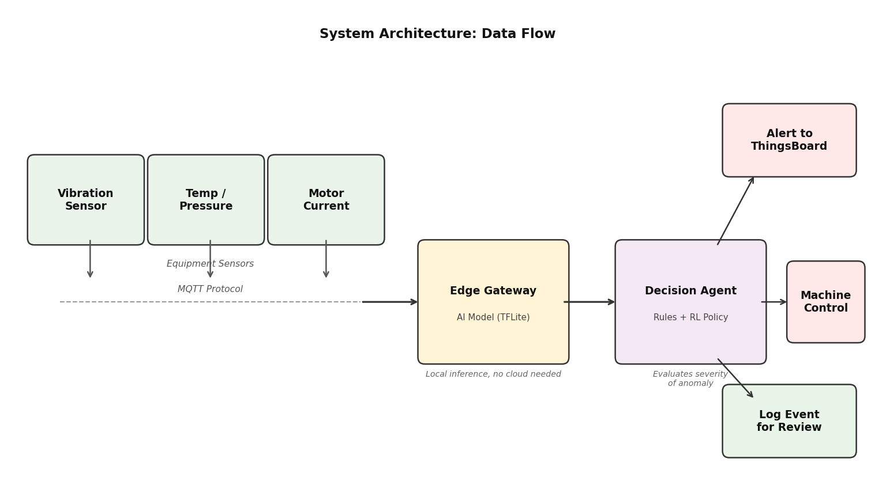
Figure 1: System Architecture — data flow from equipment sensors through the edge gateway to the decision agent and cloud dashboard

3. AI Model Development

Anomaly Detection
The main detection component is an autoencoder, a type of neural network that learns to rebuild normal input patterns and flags anything it cannot reconstruct cleanly as a possible problem, trained on long stretches of healthy operating data to build a clear picture of what normal looks like across all tracked variables. Meaningful changes become detectable even when they do not match any previously labeled failure event, making this approach well-suited for an environment where real failure data is hard to come by. To make it work on a low-power edge device, the trained network would be converted to TensorFlow Lite format, which allows fast local processing without needing cloud access.

Synthetic Data Generation
Since recorded failure events are too rare to build a solid training set on their own, a GAN would fill that gap by creating realistic pre-failure sensor sequences through a process where the generator produces made-up readings meant to resemble real failure warning signs while the other network tries to tell them apart from genuine historical data, and through that back-and-forth the generator keeps improving until its output is close enough to real data to be useful. Those examples get added into the training pipeline so the model learns to recognize both normal and problem patterns. Google Colab would handle the heavy training work and Edge Impulse would manage the model setup before the final version gets exported to the edge device.

Autonomous Decision Logic
The agent layer uses a mixed setup combining rule-based triggers for situations that need an immediate response, like a hard temperature limit being crossed, with a reinforcement learning policy for less urgent calls like recommending a maintenance window. The learning side improves over time by receiving feedback on whether its suggestions matched real issues, allowing the agent to grow more accurate as operational history builds up. This means the agent can handle both safety-critical events needing a fast automatic response and lower-stakes situations where a more careful recommendation makes more sense.
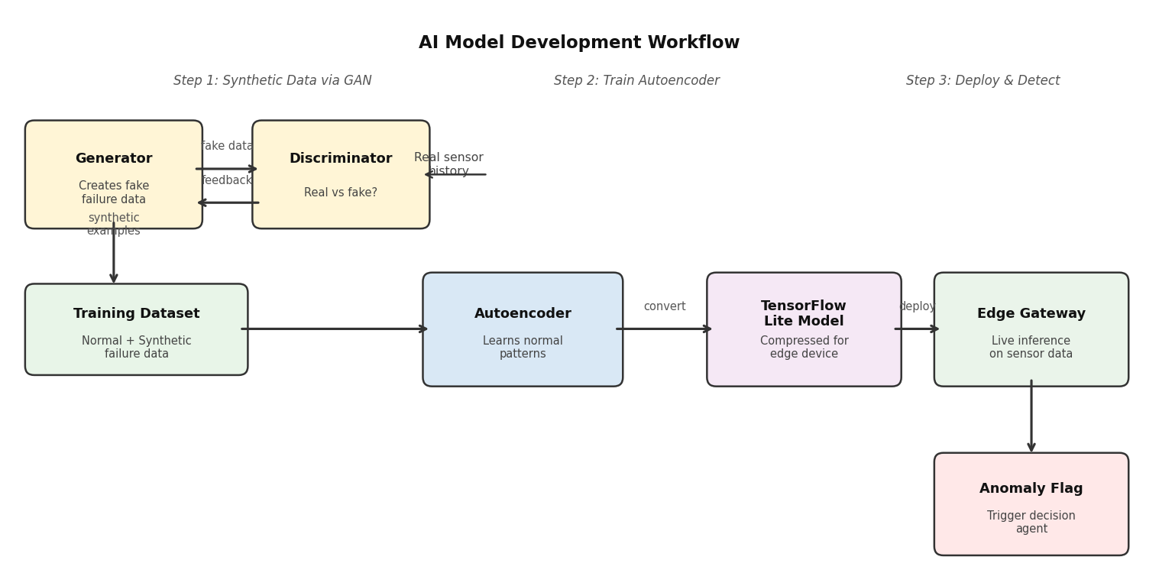
Figure 2: AI Model Workflow — GAN generates synthetic failure data, autoencoder trains on combined dataset, TFLite model deploys to edge for live detection

4. Security and Ethical Considerations
Every communication channel in this setup would be protected with TLS encryption, and each edge gateway would verify itself to the cloud using a unique device certificate so that only trusted hardware can send data through. The dashboard would be secured through role-based access controls that limit what each user can see based on their role, keeping sensitive operational data away from anyone who does not need it. Network traffic would also be watched for unusual activity as an added layer of protection on top of standard login checks.
The two biggest ethical risks are false positives, which send a technician to check on equipment that is running fine and waste time, and false negatives, which mean a real warning goes unnoticed and a failure happens that could have been avoided. Both come down to how well the training data reflects real-world conditions, and if the made-up GAN sequences only cover a narrow range of failure types the agent will have blind spots. Retraining regularly on real data as it builds up would reduce this over time, and showing the reasoning behind each alert would help maintenance workers judge how much to rely on the agent's calls.

5. Implementation and Testing Plan
If this were built out, the process would begin with GAN training in Google Colab using a dataset of normal and near-failure readings, followed by exporting the finished autoencoder as a TensorFlow Lite model ready for the edge device. Node-RED would then be set up on the gateway to handle the full data pipeline, taking in MQTT messages, running them through the model, and sending outputs to either the ThingsBoard dashboard or direct control actions depending on what the model returns. Alert thresholds and automated notifications to maintenance staff would be configured in ThingsBoard to complete the setup.
Testing would cover five situations: a normal operation run to confirm the false alert rate stays below five percent, a pre-failure injection to verify the agent correctly spots warning patterns, and a connectivity loss test to confirm the edge side keeps running on its own and saves alerts to send later. A security test would confirm that unauthorized devices and invalid logins both get blocked, and a stress test would check that response time stays under 500 milliseconds under heavy load. Across all five, the tracked measures would include detection accuracy, response speed, error rates in both directions, and uptime under poor conditions.
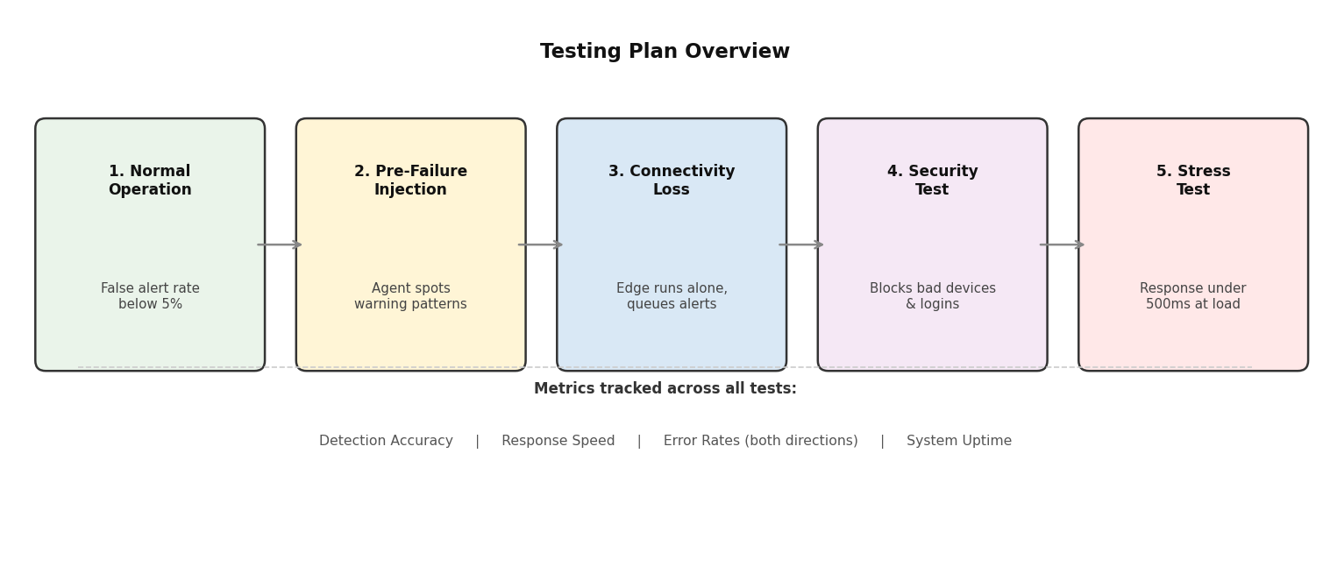
Figure 3: Testing Plan — five test scenarios with their expected outcomes and shared metrics tracked across all of them

6. Challenges, Trade-offs, and Lessons Learned
The heaviest challenge in this design is how much it depends on made-up training data, because while using a GAN to fill in for the lack of real failure records is reasonable, it brings the risk that the agent learns to recognize the artificial patterns it trained on rather than building a broader understanding of how equipment actually wears down. This cannot be fully fixed at the design stage, so the setup has to be treated as something that improves as real data gradually takes over, and documenting every real failure event from day one would be the most important habit to build. Retraining on that data regularly is what would make the agent reliable over the long run.
Deciding how much processing to put on the edge versus the cloud required careful thought, since loading more onto the gateway makes things faster but is held back by the device's limited power, while leaning too much on the cloud brings back the slow response times that edge computing is meant to solve. Keeping the deployed model as small as possible while saving heavier tasks like retraining for the cloud is the most practical balance, though it also means the edge model will need to be updated as newer versions become available. Working through this design overall made it clear that planning for what goes wrong matters far more than picking the right tools, and that way of thinking shaped every section of this document.

